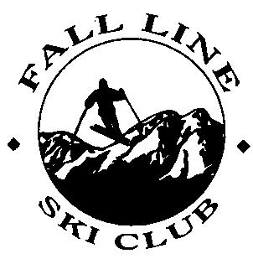
Club Med Tignes & Val D’isere, France
with post trip to Paris
March 16th to the 28th, 2024

$4,975 Regular Price (July 18 & August 15)
$5,050 Late Sign-Up Price (Sept. 19 & Oct. 17)

The ski resort Tignes/​Val d'Isère is located in the Tarentaise Valley, Savoy region, in the heart of the French Alps. It features 300 km of ski slopes serviced by a total of 79 lifts and sits between the elevations of 1,550 and 3,456 m (5,085 and 11,338 ft). Tignes and Val d'Isère form one of the largest ski resorts in France and was previously called Espace Killy. The ski resort and its slopes are partially located on glaciers. The slopes at the foot of the Pointe du Montet (3,428 m) and the Grande Motte (3,656 m) offers skiing and riding of all difficulty levels. The men's skiing competition for the 1992 Albertville Winter Olympics was held in Val d’Isère. The ski resort also regularly hosts World Cup races. Being interlinked means you can ski from the more challenging Tignes to the easier Val d'Isère and back. It is also considered one of the best areas in the world for lift served off-piste runs. With its relatively high elevation, Tignes/Val D’isere is known as one of the most snow-sure ski resorts in Europe with reliable snow from November to May.

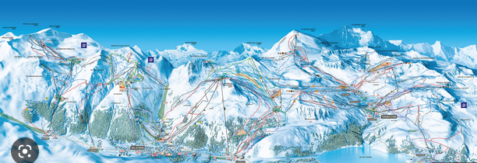
Val D’isere -Tignes Ski Resort Map

We will be staying at the new Four Star Club Med Tignes Resort, where sport and adrenaline come together in this amazing ski area suited to every skill level. The ambiance is happy and family friendly, right down to the hotel decor where the colors and patterns add pizzazz to the traditional mountain features. Your all-inclusive stay offers three meals per day in the Val Claret restaurant, unlimited snacks, Ski In – Ski Out, all beverages, open bar, wine carafes at dinner, 6 day lift pass (good at both ski resorts) and lessons, yoga sessions (Sothys Spa available at extra cost). Swim in the alps largest indoor pool, relax in the sauna & hot tub. Entertainment includes live music, DJ sets, and live entertainment in the theater that changes nightly.

The trip price includes:
❖ Round trip airfare between Newark and Geneva via Air France (No Air deduct $990.)
❖ Round-trip motor coach transportation between Geneva and Club Med Resort
❖ 7 nights lodging in Superior Rooms based on double occupancy (single supplement, see below)
❖ Buffet breakfast, lunch, and dinner daily all-inclusive package
❖ Open bar and all day beverages & snacks (premium drinks not included)
❖ 6-day Adult Lift ticket (for both ski areas) and lessons with Expert lessons or ski guiding based on abilities.
❖ Club Med Membership fee
❖ Paris Extension 4 nights, 5 days March 24-28, 2024 at the 4 star Mercure Paris Gare de Lyon TGV Hotel
❖ True Ski in – Ski out resort with heated ski lockers
❖ Rooms include kettle, tea & coffee making facilities, hair dryer & other amenities
❖ Free bus service between Tignes & Val D’isere
❖ NOTE: Trip prices quoted above are for double occupancy. The Single Supplement additional cost is $638. This is for both hotels; Club Med & the Paris Extension.
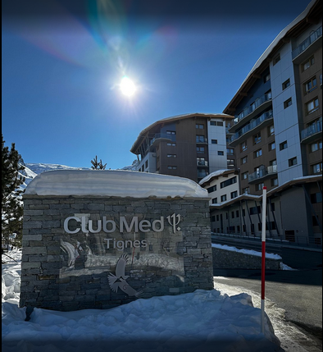
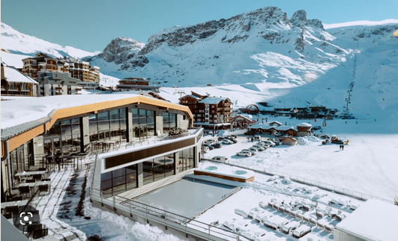

Paris Extension

At the foot of the Lyon train station, the Mercure Paris Gare de Lyon TGV hotel is ideal for travelers and a perfect location for your visit to Paris. Lyon Station has lots of transport options and easy access to the Paris Metro.. The Regional Rail Line (RER) provides direct access to the Arc de Triomphe, La Défense and Disneyland, while the metro takes you to Notre-Dame, the Louvre and the Champs-Élysées. A short walk from the hotel takes you to Le Marais, the Seine, Saint Germain-des-Prés, République, Bastille, Coulée Verte or Jardin des Plantes and restaurant and cafe options abound in the surrounding neighborhoods.
All rooms are equipped with a SMART TV CHROMECAST, a top-of-the-range bedding, free Wifi and minibar. Other amenities include a fitness center, Coffee Shop with private terrace, on site bar and room service.

Paris Package Includes:
❖ Round trip transfer from Airport Paris to Hotel
❖ 4-night accommodations based on double occupancy
❖ Coach at disposal 4 hours for city tour Paris including parking fees.
❖ English speaking guide for 4 hours for city tour Paris
❖ Daily Breakfast

Flight Schedule | Date | Airline | Depart | Time | Arrive | Time
 | Saturday, March 16 | Air France | Newark | 05:00 pm | Geneva | 06:10 am
 | Sunday March 24 | Air France | Geneva | 12:05 pm | Paris | 01:25 pm
 | Thursday, March 28th | Air France | Paris | 12:30 pm | Newark | 04:00 pm
 | Note: Current scheduled flight times, however both airline and times are subject to change.

Hotel Info. | Check-In Date | Check-Out Date | Hotel Address and Phone Number
 | Sunday March 16 | Sunday March 24 | Club Med Tignes, Av. de la Grande Motte, 73320 Tignes, France
 | Sunday March 24 | Thursday March 28 | Mercure Paris Gare de Lyon TGV Hotel 4*  2 place Louis Armand, 75012 Paris, France  +33-1-43-44-84-84

Deposit Info | Deposit:  May 16 | $800.00 | *PLEASE NOTE: First $75 is non-refundable. Price subject to change due to any costs incurred by FLSC due to the changing circumstances in the travel industry. Trip participants are responsible for any fees that may be incurred outside the control of FLSC, including but not limited to: fuel surcharges, baggage fees imposed by airlines, changes in exchange rates, costs incurred by weather related delays or cancellations. Any name change after ticketing will be subject to a $200 penalty or more imposed by the airline. Your name must match your Passport or license (a copy of which must be provided to your trip leader at signup). A $25 charge will be added if final payment is not received by the due date.
 | June 16 | $600.00
 | July 20 | $600.00
 | August 15 | $600.00
 | September 19 | $600.00
 | October 17 | $600.00
 | November 21 | Balance

Cancellation Policy | After | Amount | Attempts will be made to provide a suitable roommate, but if one is not found, or if a cancellation leaves you or your roommate single, the single supplement cost will apply if a suitable roommate is not available or you will have the option to cancel from the trip.
 | September 20th | Up to $300
 | October 18th | Up to $1,500
 | After November 15th | Up to the full price of the trip plus any expenses incurred by FLSC
 | Note: No shows will receive no refund and will be responsible for any expenses incurred by FLSC. You are not considered canceled until you have notified and been acknowledged by the trip leader.

Note: Trip Insurance is recommended. See Trip Leader for details.

Make checks payable to: FLSC (Fall Line Ski Club) and put name of trip in description.
Trip Leader: Contact Steve Umansky steven.umanski@yahoo.com or Ken Koch kennethkochster@gmail.com for more information.
---------------------------------------------------------------------------------------------------------------------------------

August 16, 2023 Revisions

