HEAVENLY – LAKE TAHOE, CALIFORNIA/NEVADA
January 27th to February 3rd, 2024
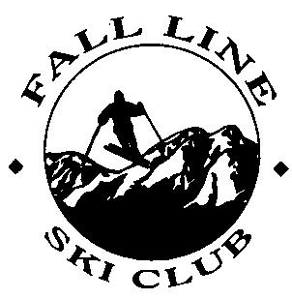
*EPSC Winter Carnival* Best Hotel!!

$2,700 Early Sign-Up Price with Epic Pass (May & June)
$2,775 Regular Price with Epic Pass (July & August)
$2,850 Late Sign-Up Price with Epic Pass (Sept. & October)

Have you ever skied from one state to another? Can you imagine a ski slope high above a sapphire blue lake? You achieve both feats at Margaritaville Resort Lake Tahoe! Take the Dipper Express Four-Pack, hop off and decide. Your choices are huge: ski California or Nevada? Will it be 34 miles of wide-open, groomed cruisers, 1,600-foot plunges in the double-black diamond canyons or the most outrageous tree skiing in North America?

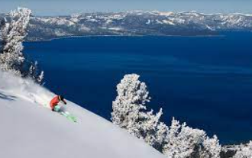

Heavenly ski area details:

- 4,800 skiable acres  - 3,500 vertical feet  - Base elevation: 7170 feet  - Summit elevation: 10,067 feet  - 113 total trails |  | - Trail breakdown: 7% Beginner. 60% Intermediate. 27% Advanced & 5% Expert.  - 28 Lifts including 2 gondolas & tram, 2 six-packs, 8 Quads, 3 double chair, 5 triples, & 8 surface lifts.  - Longest trail: 5.5 miles!
Our stay at Margaritaville Resort Lake Tahoe , includes a one-hour welcome happy hour with light snacks. During the week, the hotel offers reduced happy hour drink prices, daily. Heavenly’s gondola, just a short walk from the hotel, is your gateway to the slopes to start your day. At day’s end, simply drop your equipment at the rental shops, at ski lockers or the hotel’s ski-valet. Along the way are many great places, both indoor & out, for a drink to soak up the last of the day’s sun & fun. Then head to the hotel’s indoor pool, hot tub, sauna, fitness room, etc. You will find the Lake Tahoe Resort Hotel to be a fun, social gathering spot, sitting in the middle of all the action.
The trip price includes:

- Transportation between Philly and Reno Airport on TBD (no air deduct $)  - Round-trip motor coach transportation between Reno Airport and Lake Tahoe Resort Hotel  - 7 nights lodging at the Lake Tahoe Resort Hotel with Queen & King bed options.  - Lift Tickets NOT included. Go to http://www.sportsamerica.com/epic-fallline ($348 for 5-Day Pass)  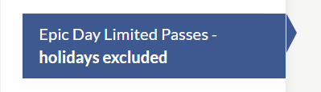 |  | - Welcome Happy Hour Reception  - Group Welcome Party: Sunday  - Après Race Registration Party: Monday  - Ski Northstar includes lunch: Tuesday  - Mid-Week Gala: Dinner & Drinks!  - VIP Mountain Tour  - Optional Non-Ski Excursions available  - Custom ESPC Trip Souvenir  - Fall Line Ski Club personal luggage tags

Flight Schedule | Date |  | Airline | Depart | Time | Arrive | Time
 | Saturday, January 27th |  |  | Philly |  | Reno
 | Saturday, February 3rd |  |  | Reno |  | Philly

Hotel Info. | Check-In Date | Check-Out Date | Hotel Address and Phone Number
 | January 27, 2024 | February 3, 2024 | Lake Tahoe Resort Hotel  4130 Lake Tahoe, CA 96150  530-544-5400

Deposit Info | May 16th, 2023 | $475.00 | *PLEASE NOTE: First $75 is non-refundable. Price subject to change due to any costs incurred by FLSC due to the changing circumstances in the travel industry. Trip participants are responsible for any fees that may be incurred outside the control of FLSC, including but not limited to: fuel surcharges, baggage fees imposed by airlines, changes in exchange rates, costs incurred by weather related delays or cancellations. Any name change after ticketing will be subject to a $200 penalty or more imposed by the airline. Your name must match your Passport or license (a copy of which must be provided to your trip leader at signup). A $25 charge will be added if final payment is not received by the due date.
 | June 20th | $450.00
 | July 18th | $450.00
 | August 15th | $450.00
 | Sept. 19th  Oct. 17th | $450.00  Balance

Cancellation Policy | After | Amount | Attempts will be made to provide a suitable roommate, but if one is not found, or if a cancellation leaves you or your roommate single, the single supplement (TBD) will apply if a suitable roommate is not available, or you will have the option to cancel from the trip.
 | Sept. 19th | Up to  $100
 | October 17th | Up to $800
 | After Nov 1st | Up to the full price of the trip plus any expenses incurred by FLSC
 | Note: No shows will receive no refund and will be responsible for any expenses incurred by FLSC. You are not considered canceled until you have notified and been acknowledged by the trip leader.
Make checks payable to: FLSC (Fall Line Ski Club) and put name of trip in description.
Trip Leader: Contact Kathy Smith ~ Kabob2x@verizon.net for more information.

